**Come Tour Cityline’s Martin with Livable Sunnyvale.**

Wednesday, August 7, 2024 at 5:30PM

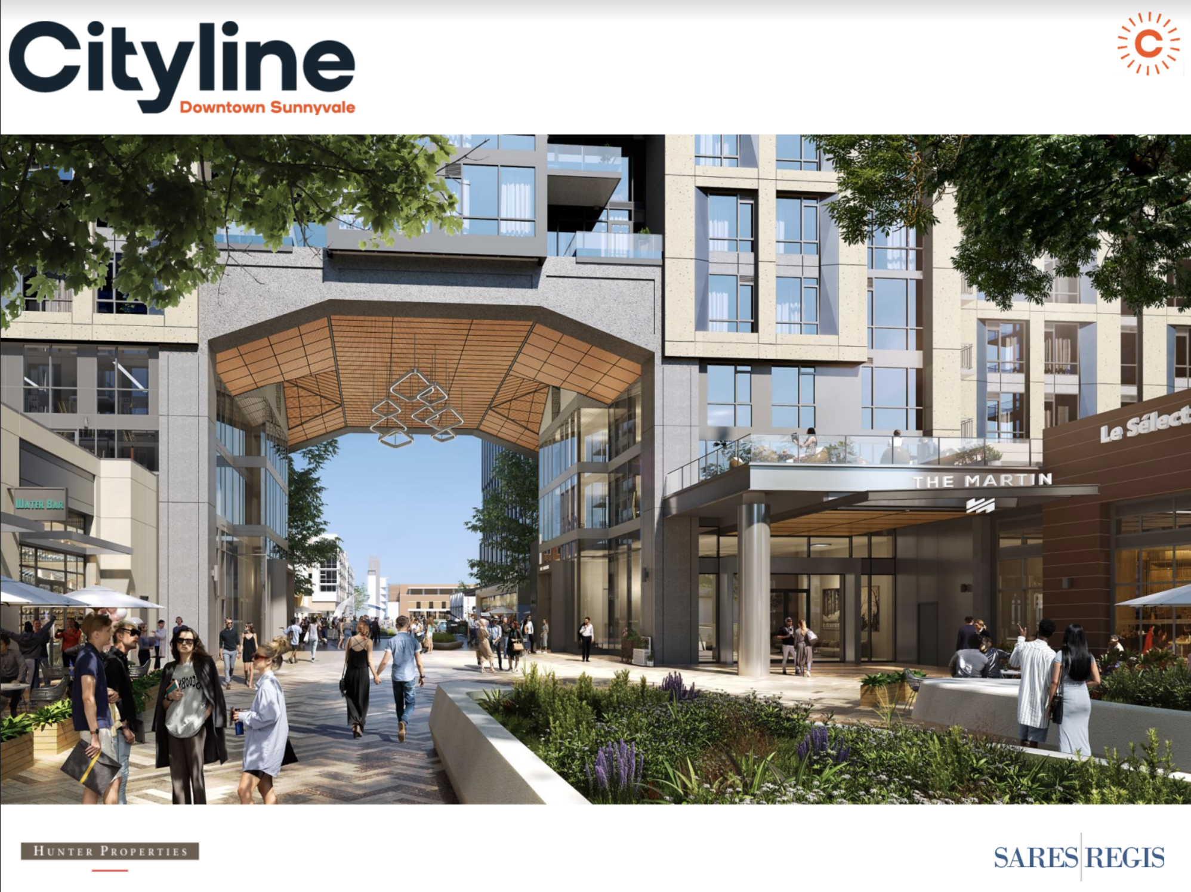

# RSVP at https://www.eventbrite.com/e/livable-sunnyvale-tours-citylines-martin-apartments-tickets-965478721847

In person event only, 241 S. Taaffe Street, Sunnyvale, CA